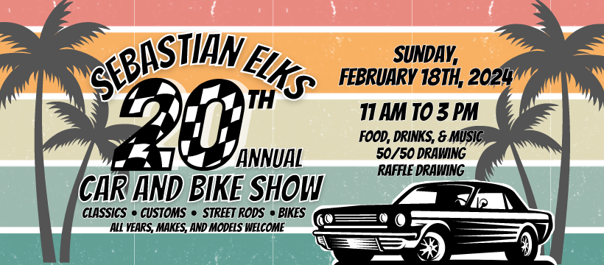
GOLD SPONSOR / AWARD PRESENTOR  $1,000 +  - Presentation of awards for your sponsored Car Show Category  - Listing as a Primary Sponsor on t-shirts. (Logo must be received by Jan 20, 2024 to be included)  - Recognition on Event Facebook page with link to your website.  - Business name announced as major sponsor during the Car Show (minimum 4 times)  - Display area provided either inside by our chance raffle space or outside as part of the show.  - Provided an area at the entrance of the show to display a banner listing as the Primary Sponsor of the Show.  - Right of Exclusivity | SILVER SPONSOR  $500  - Listing as a Sponsor on T-shirts. (Logo must be received by Jan 20, 2024 to be included)  - Recognition on Event Facebook page with link to your website.  - Business name announced as a sponsor during the Car Show  - Display area provided either inside by our chance raffle space or outside as part of the show.  Provided an area at the entrance of the show to display a banner listing as the Primary Sponsor of the Show.
BRONZE SPONSOR  $250  - Listing as a Sponsor on T-shirts. (Logo must be received by Jan 20, 2024 to be included)  - Recognition on Event Facebook page with link to your website.  - Business name announced during the Car Show  - Mention on a Sponsor/Contributor Thank-You Sign at the entrance of the show. | GOODY BAG SPONSOR  **$$ and Product/Service  - _______________ (minimum qty. 100)  - $______________ (value US dollars)  Item Description________________________________________
RAFFLE/IN KIND SPONSOR  **$$ and Product/Service  - $ ____________ (US dollars)  - $ ____________ (product or service)  Please list product or service being offered:  ____________________________________________________  ____________________________________________________  **In Kind Sponsor total contribution values determine benefits offered as provided for above listed sponsor level (excluding right of exclusivity benefit) | T-Shirt Pre-Order  SM ______ Med _____ Large_____ XL ______ $10 each  2XL_____ 3XL _______ $12 each  Total T-Shirt Order $ ____________  (day of show $15 - $17 limited availability)

Business Name: __________________________________ Phone: _______________________________

Address:_________________________________________________________________________________

Contact Name: _________________________________ Auth Signature: __________________________

Please mail to Dan Talbott 8085 133rd Place Sebastian, FL 32958 or call 321-831-8105 for pick up. Form can also be e-mailed to elkscarshow@gmail.com. Make checks payable to Sebastian Elks #2714
Like us on Facebook https://www.facebook.com/elkscarshow
